**Signal Analysis Lab 3**

**To find the convolution sum of two discrete-time sequences in Matlab**

**Convolution Sum:-**

*y*[*n*]=*x*[*n*]\**h*[*n*]



Suppose,



$$x\left[n\right]=\left\{\begin{aligned}\frac{1}{3}n for 0≤n≤6 \\ 0 , Otherwise\end{aligned}\right.$$

$$h\left[n\right]=\left\{\begin{aligned}1, for-2≤n≤2 \\ 0, Otherwise\end{aligned}\right.$$

*h*[*n*] = {0, 0, 1, 1, 1, 1, 1, 0, 0}

Finally,

y[*n*] = {0, 1/3, 1, 2, 10/3, 5, 20/3, 6, 5, 11/3,2}

**Code:**

**x=[0,1/3,2/3,3/3,4/3,5/3,6/3]**

**n1=[0,1,2,3,4,5,6]**

**nx=length(x)**

**h=[1,1,1,1,1]**

**n2=[-2,-1,0,1,2]**

**nh=length(h)**

**y=conv(x,h)**

**nmin=min(min(n1),min(n2))**

**n=nmin:1:nx+nh-2+nmin**

**subplot(2,2,1)**

**stem(n,y)**

**xlabel('n');**

**ylabel('y[n]');**

**subplot(2,2,2)**

**stem(n1,x)**

**xlabel('n');**

**ylabel('x[n]');**

**subplot(2,2,3)**

**stem(n2,h)**

**xlabel('n');**

**ylabel('h[n]');**

**Working:-**

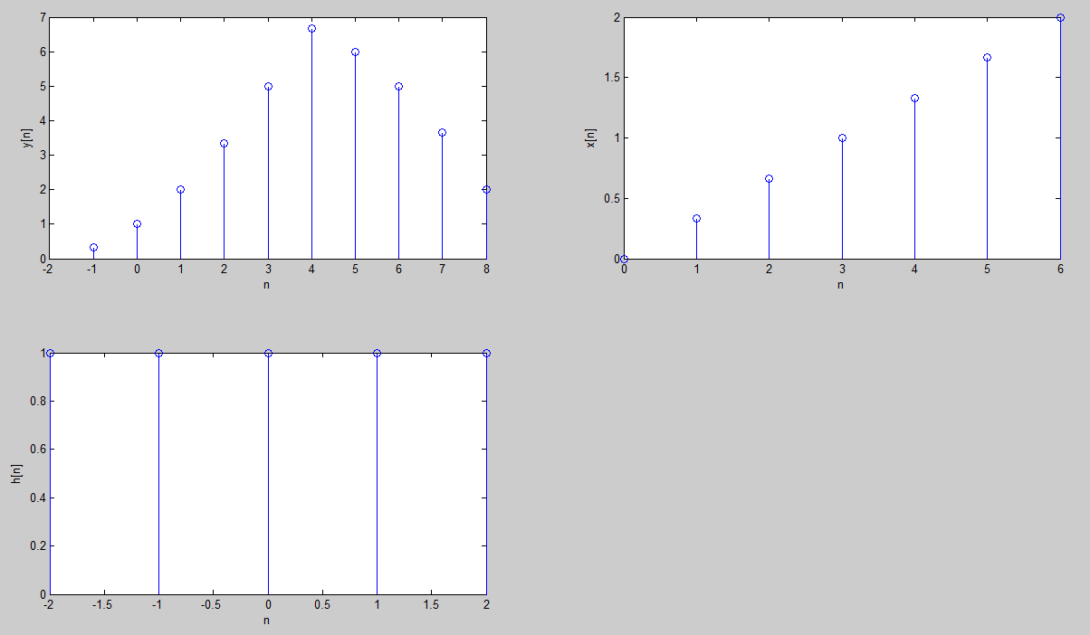

**Task #2: Repeat the same for**

x[n]={1,2,1,2}

h[n]={2,2,-1,1}

**Answer:**

y[*n*] = {2, 6, 5, 5, 5, -1, 2}